*Chapter 1*

# INTRODUCTION

__________________________________________

A well-designed car selling and buying website should feature a user-friendly interface with advanced search functionality and responsive design, allowing users to easily navigate listings that include detailed descriptions, high-quality images, and comparison tools. It must facilitate sellers with an instant valuation tool, a straightforward listing process, and direct communication options with potential buyers. For buyers, the platform should offer financing calculators, test drive scheduling, and secure payment processing. Additional services like vehicle history reports, customer support, and user reviews will enhance trust and satisfaction. Lastly, effective marketing strategies such as SEO optimization and social media integration are essential for attracting users and promoting listings successfully.

This project utilizes a combination of **HTML, CSS, JavaScript, PHP, and MySQL** to build a comprehensive platform that manages various aspects of car buying and selling, from student registrations to interview scheduling. Each technology plays a crucial role in ensuring that the system is both functional and user-friendly.

* **HTML** (HyperText Markup Language) forms the structural backbone of the web application, defining the content and layout of the pages. As the fundamental language for web development, HTML is crucial for structuring information in a way that is accessible and organized.
* **CSS** (Cascading Style Sheets) is employed to control the visual presentation of the web pages, allowing for the separation of content from design. This separation ensures that the user interface is aesthetically pleasing and responsive across various devices.
* **JavaScript** adds interactivity to the platform, enabling dynamic content updates, form validations, and enhanced user experiences without requiring page reloads. This interactivity is essential for creating a responsive and user-centric application.
* **PHP** (Hypertext Preprocessor) serves as the server-side scripting language, handling the business logic, database interactions, and user authentication processes. It ensures that the application is capable of processing complex tasks efficiently.
* **MySQL** is used as the database management system, storing and managing all essential data, including student profiles, job postings, and application statuses. MySQL's robust database capabilities provide the foundation for secure and efficient data handling.

## 1.1 HTML (HyperText Markup Language)

HTML is the standard language used to create and organize content on the web, forming the structural backbone of webpages. It uses a system of tags and elements to define different types of content, such as text, links, images, and multimedia. HTML ensures content is properly structured and accessible, which is essential for search engine optimization and web accessibility. As the fundamental technology for web development, proficiency in HTML is crucial for any web developer.

## Origins of HTML

* **1989**: HTML was conceptualized by Tim Berners-Lee at CERN to facilitate the sharing and linking of information.
* **1990**: Berners-Lee developed the initial specifications for HTML, along with the first web server and browser/editor, WorldWideWeb.
* **1991**: The first public version of HTML, HTML 1.0, was released, enabling basic web page creation.
* **1997**: The W3C released HTML 4.0, introducing significant improvements like support for complex web applications and internationalization.
* **2014**: HTML5 was officially published as a W3C Recommendation, introducing new features to support modern web applications.

**Key Features of HTML**

* **Structure and Semantics**: HTML (HyperText Markup Language) provides the foundational structure and meaning of web content. It uses a system of tags (<h1>, <p>, <div>, etc.) to define headings, paragraphs, sections, and other content types, ensuring that web pages are properly structured and accessible.
* **Hyperlinking**: HTML enables linking between web pages using the <a> (anchor) tag, which is essential for web navigation and the interconnected nature of the internet.
* **Multimedia Integration**: HTML allows for the embedding of multimedia elements such as images (<img>), videos (<video>), and audio (<audio>), enhancing the richness and interactivity of web content.
* **Form Creation**: HTML provides tags like <form>, <input>, <textarea>, <button>, and others to create forms for collecting user data, enabling functionalities such as user registration, login, and data submission.
* **SEO-Friendly**: Proper use of HTML elements like <h1>, <title>, <meta>, <alt>, etc., contributes to search engine optimization (SEO), helping web pages rank higher in search engine results.
* **Cross-Platform Compatibility**: HTML is a standardized language that is supported by all modern web browsers, ensuring consistent display and behavior across different devices and platforms.
* **Accessibility**: HTML supports accessibility features such as ARIA (Accessible Rich Internet Applications) roles and attributes, ensuring web content is accessible to users with disabilities.

## 1.2 CSS (Cascading Style Sheets)

CSS is the language used to describe the presentation of a document written in HTML. It controls the layout, colors, fonts, and overall visual appearance of web pages. CSS enables developers to separate content from design, making it easier to maintain and update websites. Mastery of CSS is essential for web developers to create aesthetically pleasing and responsive designs.

**CSS Origins**

* **1996**: CSS was first proposed to provide a standardized way to style web documents.
* **1997**: The W3C published the first CSS standard, CSS1, enabling basic styling capabilities.
* **1998**: CSS2 was released, introducing more sophisticated layout and design capabilities.
* **2011**: CSS2.1 became a W3C Recommendation, refining CSS2 features.
* **1999**: Work began on CSS3, which introduced features like rounded corners, shadows, and flexible layouts.

**Key Features of CSS**

* **Styling and Layout**: CSS (Cascading Style Sheets) is used to control the visual presentation of HTML elements, including colors, fonts, spacing, and layout. This enables developers to create visually appealing web pages that enhance the user experience.
* **Responsive Design**: CSS includes media queries and flexible grid systems that allow for responsive design, ensuring web content is optimized for various screen sizes and devices, from desktops to smartphones.
* **Animations and Transitions**: CSS provides powerful animation and transition effects that can be applied to elements for smoother and more engaging visual interactions, such as hover effects, fades, and dynamic movements.
* **Selector and Inheritance Mechanism**: CSS uses selectors (like .class, #id, and element) to target and style specific HTML elements. The cascading nature of CSS ensures that styles are inherited and applied based on specificity and hierarchy.
* **Separation of Content and Presentation**: CSS separates the design and presentation aspects of a web page from its structure, allowing for cleaner code, easier maintenance, and the ability to apply consistent styling across multiple pages.
* **Custom Fonts and Icons**: CSS allows the use of custom web fonts (@font-face) and icons, providing flexibility in typography and visual design, enhancing brand identity and aesthetics.
* **Cross-Browser Compatibility**: CSS is supported by all modern browsers, and with the help of CSS frameworks (like Bootstrap) and vendor prefixes, developers can ensure consistent styling across different platforms and browsers.

## 1.3 JavaScript

JavaScript is a versatile and powerful programming language that enables the creation of dynamic and interactive web content. Unlike HTML and CSS, which focus on the structure and style of web pages, JavaScript allows developers to add interactivity, control multimedia, animate images, and handle user inputs in real time. JavaScript can be run both on the client side and the server side, making it a key component of modern web development.

**JavaScript Origins**

* 1995: JavaScript was created by Brendan Eich while working at Netscape Communications Corporation. Originally named Mocha, it was later renamed to LiveScript and finally to JavaScript to reflect its new positioning as a scripting language that complemented Java (though it is distinct from Java).
* 1996: Netscape submitted JavaScript to ECMA International for standardization. The result was ECMAScript, the official name of the standardized scripting language.
* 1997: The first edition of ECMAScript (ES1) was released, establishing the foundation for the JavaScript language.
* 2009: ECMAScript 5 (ES5) was released, introducing significant features such as "strict mode," JSON support, and new methods for arrays and objects.
* 2015: ECMAScript 6 (ES6), also known as ECMAScript 2015, was a major update that introduced many modern features like classes, modules, arrow functions, template literals, and let/const for block-scoped variables.
* Ongoing Development: JavaScript continues to evolve with yearly updates to the ECMAScript standard, bringing new features and improvements that keep the language at the forefront of web development.

**Key Features of JavaScript**

* Interactivity: JavaScript enables the creation of interactive elements on web pages, such as dropdown menus, sliders, and form validations, enhancing user engagement.
* Asynchronous Programming: JavaScript supports asynchronous operations through callbacks, promises, and async/await, allowing for tasks like data fetching and handling without blocking the main thread.
* Cross-Browser Compatibility: JavaScript is supported by all major web browsers, making it a universal language for web development.
* Event Handling: JavaScript allows developers to capture and respond to user events like clicks, keystrokes, and mouse movements, creating a dynamic user experience.
* DOM Manipulation: JavaScript provides powerful APIs to manipulate the Document Object Model (DOM), enabling dynamic changes to the content and structure of web pages.
* Client-Side and Server-Side Development: While traditionally used on the client side, JavaScript can also be used on the server side with environments like Node.js, enabling full-stack development.

## 1.4 PHP (Hypertext Preprocessor)

PHP is a widely-used open-source server-side scripting language that is particularly suited for web development. It is embedded within HTML, making it an efficient tool for creating dynamic and interactive web pages. PHP executes on the server, generating HTML that is sent to the client’s browser, ensuring a smooth user experience.

**PHP Origins**

* 1994: PHP was created by Rasmus Lerdorf as a set of Common Gateway Interface (CGI) binaries written in the C programming language. It was originally designed to track visits to his online resume.
* 1995: PHP was released to the public as "Personal Home Page Tools" (PHP Tools), allowing developers to build dynamic web applications.
* 1997: PHP 3.0 was released, marking the transition to a full-fledged scripting language and rebranding it as "PHP: Hypertext Preprocessor."
* 2000: PHP 4.0 introduced the Zend Engine, significantly improving performance and adding support for session management.
* 2004: PHP 5.0 was released, introducing support for object-oriented programming (OOP) and the integration of the MySQLi extension for better database interaction.
* 2015: PHP 7.0 brought substantial performance improvements with the new Zend Engine 3.0, along with support for return type declarations and new error handling features.
* 2020: PHP 8.0 introduced the JIT (Just-In-Time) compiler, improving execution speed and bringing new features like union types and attributes.

**Key Features of PHP**

* Cross-Platform Compatibility: PHP runs on various platforms, including Windows, Linux, and macOS.
* Easy Integration: PHP integrates seamlessly with various databases, including MySQL, PostgreSQL, and SQLite.
* Security: PHP provides built-in functions and tools for securing web applications, including input validation and encryption.
* Flexibility: PHP supports various web servers, including Apache and Nginx, and can be used to build a wide range of applications, from simple websites to complex enterprise systems.

PHP is crucial for server-side logic in your car selling and buying, handling tasks like user authentication, form processing, and data management. Its integration with MySQL allows for efficient communication between the web application and the database.

## 1.5 MySQL

MySQL is a powerful open-source relational database management system (RDBMS) that is used to store, organize, and retrieve data efficiently. It is one of the most popular databases used in web applications due to its reliability, scalability, and ease of use. MySQL is often paired with PHP in the LAMP stack (Linux, Apache, MySQL, PHP) to build dynamic and datadriven websites.

**MySQL Origins**

* 1995: MySQL was developed by Michael Widenius, David Axmark, and Allan Larsson in Sweden. The name "MySQL" was inspired by Widenius's daughter, My.
* 1996: The first version of MySQL was released to the public, quickly gaining popularity due to its speed and ease of use.
* 2000: MySQL AB, the company behind MySQL, signed a partnership with SAP, enhancing its enterprise capabilities.
* 2008: Sun Microsystems acquired MySQL AB, further investing in its development.
* 2010: Oracle Corporation acquired Sun Microsystems, becoming the official steward of MySQL.

**Key Features of MySQL**

* Relational Database Structure: MySQL organizes data into tables with relationships, ensuring data integrity and reducing redundancy.
* Scalability: MySQL can handle small-scale applications as well as large-scale enterprise systems, capable of managing millions of rows of data.
* Performance: MySQL is optimized for high performance, with features like indexing, query caching, and replication to support fast and efficient data retrieval.
* Security: MySQL offers strong security features, including user authentication, SSL support, and data encryption.

*Chapter 2*

# Requirements Specification

______________________________________________  
In the realm of online commerce, a well-defined set of requirements is essential for creating a user-friendly and reliable car selling and buying platform. This chapter outlines the functional and non-functional requirements of the Car Selling and Buying Website, focusing on user experience, system performance, reliability, security, and data integrity. The goal is to ensure that both buyers and sellers can engage in seamless transactions within a secure environment.

**2.1 Functional Requirements**

1. **User Registration and Login**
   * Users (buyers and sellers) must be able to register by creating an account, providing necessary details like email, password, phone number, and vehicle-related information.
   * Users can log in using their credentials to access personalized content and features.
2. **Posting a Car for Sale**
   * Sellers should be able to post a car listing by entering details such as car make, model, year, mileage, price, and adding images/videos of the car.
   * The system should validate the inputs and allow modifications to the listing after it is posted.
3. **Searching for Cars**
   * Buyers can search for cars based on various criteria such as make, model, price range, location, year, and mileage.
   * The search results should display relevant car listings with options to filter and sort the results.
4. **Viewing Car Details**
   * Buyers should be able to view the details of each car listing, including a description, images, price, seller contact information, and car specifications.
5. **Contacting the Seller**
   * Buyers can directly contact the seller via an integrated messaging system or through contact details provided in the listing.
6. **Price Negotiation**
   * The system should allow buyers and sellers to negotiate the price through a built-in chat system or price suggestion feature.
7. **Purchasing Process**
   * Once a buyer decides to purchase, the website should offer options for secure payment gateways and invoice generation.
   * The system should provide a clear purchase agreement to both parties, confirming the transaction.
8. **Feedback and Ratings**
   * After the transaction, buyers can rate and provide feedback about the seller and the car.
   * Sellers can also rate buyers, ensuring a trust-building system.

**2.2 Non-Functional Requirements**

1. **Performance**
   * The website should load within 3-5 seconds to ensure a smooth user experience.
   * Car listings and search functionalities should return results with minimal delay (under 500 milliseconds).
   * Data entry and updating listings should be responsive and efficient.
2. **Reliability**
   * The system should provide high uptime (99.9%) and handle user traffic efficiently, even during peak hours.
   * In case of failures, the system should gracefully handle errors, notify users, and recover without data loss.
3. **Usability**
   * The website should have a simple and intuitive design that supports both novice and experienced users.
   * All notifications, error messages, and instructions should be clear, concise, and user-friendly.
   * The platform must be accessible via both desktop and mobile devices.
4. **Security**
   * User data (including personal details and payment information) must be protected using SSL/TLS encryption.
   * Strong user authentication and authorization mechanisms (such as two-factor authentication) should be implemented.
   * Input validation to prevent common security threats like XSS and SQL injection should be employed.
   * All payment transactions should be securely processed through third-party payment gateways.
5. **Interoperability**
   * The platform must be compatible with modern browsers (e.g., Chrome, Firefox, Safari).
   * The system should integrate with third-party services like payment gateways, maps, and car review APIs.

**2.3 Domain Constraints**

1. **Hardware Limitations**
   * The website should be optimized to run on standard web hosting environments with minimal hardware requirements (2GB RAM, 2 CPU cores).
2. **Software Dependencies**
   * The platform must rely on a modern web framework (e.g., React, Angular, or Vue.js) for frontend and a scalable backend such as Node.js, Django, or Ruby on Rails.
   * Uses JavaScript libraries (e.g., jQuery, Axios) to enhance user interaction and dynamic content.
3. **Dependencies on Third-Party Systems**
   * The platform must integrate with external APIs for car valuation, vehicle history reports, and other car-related services.
   * Payment processing through third-party gateways (e.g., PayPal, Stripe) must be implemented for secure transactions.
4. **Parallel Operations**
   * The platform should support multiple users browsing, posting, and messaging simultaneously without noticeable slowdowns or errors.
5. **Safety/Security Considerations**
   * **Data Encryption:** Ensure all personal data is encrypted both at rest and during transmission.
   * **Secure Payments:** All payments must use secure, PCI-compliant payment processors.
   * **Session Management:** Proper session management should be implemented to prevent unauthorized access to user accounts.
   * **Error Handling:** All errors must be caught and logged, and error messages should not expose sensitive system or user information.

*Chapter 3*

# Requirements Analysis

______________________________________________

The Car Selling and Buying System (CSBS) is designed to facilitate and streamline the process of buying and selling vehicles. It aims to provide a structured, user-friendly platform where buyers and sellers can interact, ensuring an efficient transaction process. This chapter outlines the system's design and components, focusing on the system's main functionalities, user interface, and backend structure, as well as its modular components.

The CSBS system offers six main functions: listing a car for sale, viewing car listings, deleting a listing, searching for a car, viewing car history and status, and viewing seller eligibility. These functions are designed to enhance the user experience, reduce manual processes, minimize errors, and ensure accurate and effective data management.

Through this system, buyers can easily find cars that meet their criteria, and sellers can effectively list their vehicles for sale, ensuring a seamless process for both parties. The CSBS platform integrates key features that support scalability, enabling the system to adapt to evolving market demands and trends.

**3.1 Overall System Description**

The Car Selling and Buying System (CSBS) integrates several components to facilitate smooth transactions between buyers and sellers. The system is composed of modules that handle the car listings, user interactions, and transaction processes. The front-end will provide a user-friendly interface for buyers and sellers, while the back-end will manage the database, listings, user data, and vehicle details.

The CSBS system utilizes technologies such as PHP, MySQL, and JavaScript to handle user interactions, dynamic content rendering, and database management. The system ensures seamless communication between the front-end and back-end, making it easy for users to list cars for sale, browse available vehicles, and make informed decisions based on detailed information.

**Main Menu Overview:**

Once logged in, the user will see a main menu that provides the following options:

1. **List a Car for Sale:**
   * Sellers can add a car to the system by entering essential details such as the car model, make, year, price, and additional features.
2. **View Listings:**
   * Users (buyers and sellers) can view all active car listings, filtering them based on parameters like price, make, model, and location.
3. **Delete a Listing:**
   * Sellers can delete their car listings by entering the respective car ID. If the car is listed, it will be removed from the system; otherwise, an appropriate error message is displayed.
4. **Search for a Car:**
   * Buyers can search for cars based on specific criteria such as make, model, year, price range, and location.
5. **View Car History:**
   * Buyers can view the vehicle’s history, including accident reports, service records, and ownership details, to ensure transparency and informed decision-making.
6. **View Seller Eligibility:**
   * View the eligibility criteria for sellers, including account verification and transaction history, to maintain trust and ensure quality listings.

**3.2 Components/Subsystem Design**

**Create Listing Module**

The **Create Listing Module** allows sellers to list their cars by entering vehicle details and uploading photos. This module also checks for duplicate entries and updates the system accordingly. A file system is used to manage the car listings, and once the listing is successfully added, it appears in the available cars for sale.

* **File Handling**: Car listings are stored in a database and can be edited or deleted as needed.
* **Car Details**: Car make, model, year, price, features, mileage, condition, etc.
* **Display Listings Module:** The Display Listings Module allows users to view all available car listings. Users can filter these listings by different criteria, including price, make, model, and location. This module ensures that the listings are displayed in an easy-to-navigate format with car details, photos, and seller contact information.
* **Delete Listing Module**: The Delete Listing Module provides functionality for sellers to remove a specific car listing. Sellers can delete their listing by entering the unique car ID or other identifying details. If the car exists in the system, it will be removed; if not, an error message is shown.
* **View Car History Module :**The View Car History Module allows potential buyers to access the history of a particular car. This module integrates with third-party services to retrieve accident reports, service history, and previous ownership details, offering transparency to the buyer.
* **View Seller Eligibility Module**: The View Seller Eligibility Module displays information about the seller’s eligibility based on their account verification and transaction history. It helps buyers determine the trustworthiness of a seller before proceeding with a purchase.
* **Search Car Module :** The Search Car Module provides a search functionality that allows users (buyers) to search for cars using specific parameters such as make, model, price range, location, or features. This search system uses an efficient query mechanism to retrieve relevant results quickly.
* **General Ledger Management :** The General Ledger Management feature helps track all activities within the system. It allows users to view the history of changes made to listings and transactions. The system also records interactions between buyers and sellers, providing a transparent history of all transactions.

The system maintains a journal of all car listings and updates, which is essential for ensuring that both buyers and sellers are aware of any changes made to the listings, and any disputes can be traced back to their source.

* **Transaction History**: Tracks transactions between buyers and sellers.
* **Verification Records**: Ensures that the listings and transactions are legitimate.

**3.3 Domain Constraints**

* **Hardware Requirements**: The system must run on standard hardware, such as a web server with a minimum of 1 GB RAM and 100 GB storage.
* **Dependencies**:
  + A modern web browser (Chrome, Firefox, Safari) supporting HTML5, CSS3, and JavaScript.
  + A web server (Apache, Nginx) to host the platform.
  + A database system (MySQL or MongoDB) for storing car listings and user data.
* **Security Considerations**:
  + Secure communication (HTTPS) for data encryption.
  + Input validation to prevent SQL injection, Cross-Site Scripting (XSS), and other security threats.
  + User authentication and authorization to protect personal data and ensure transaction security.
  + Session management to prevent unauthorized access.

*Chapter 4*

**TECHNOLOGIES USED**

***__________________________________________***

In the rapidly evolving landscape of web development and application creation, the integration of diverse technologies is essential for building robust, scalable, and efficient applications. This chapter explores the wide range of tools, frameworks, and languages that form the foundation of modern web and software development, each contributing to various aspects of the development process.

HTML and CSS are fundamental to web development, with HTML5 providing the essential structure of web pages and technologies like Web Components, Polymer, and Lit Element enhancing the dynamic capabilities of web applications. CSS, augmented by preprocessors such as Sass and Less, postprocessors like PostCSS, and frameworks like Bootstrap and Tailwind CSS, enables responsive and visually appealing designs. Additionally, CSS-in-JS libraries, including Styled Components and Emotion, offer innovative ways to style components in JavaScript-driven applications.

JavaScript emerges as a versatile and powerful language that drives both client-side and server-side development. Tools like Node.js empower developers to build fast, scalable server-side applications, while frameworks like React, Angular, and Vue.js provide efficient, component-based approaches to crafting interactive user interfaces.

Java technologies are represented by robust frameworks such as Spring and Hibernate, which support the creation of secure and maintainable applications. Tools like Maven and Gradle streamline build processes, while application servers like Apache Tomcat and JBoss/WildFly offer reliable deployment environments.

Python's extensive range of technologies, including web frameworks like Django and Flask, data analysis libraries like Pandas and NumPy, and machine learning tools such as TensorFlow and scikit-learn, highlight its adaptability for various applications. Package managers like pip and conda further simplify dependency management and deployment.

This chapter delves into the significance of these technologies and frameworks in modern web and software development. By examining how HTML, CSS, JavaScript, Java, and Python collectively contribute to the development of dynamic, responsive, and high-performance applications, this chapter aims to provide a comprehensive overview of the technological landscape that underpins today's web development.

**4.1 HTML (HyperText Markup Language)**

HTML, or HyperText Markup Language, is the foundation of web development, serving as the standard markup language for creating web pages. It consists of a series of elements or tags that structure content on the web, defining the various parts of a webpage such as headings, paragraphs, images, links, and more. HTML is essential for creating the it accessible to beginners and experienced developers alike. By using tags like <p> for paragraphs, <h1> for headings, and <img> for images, developers can easily create structured content that is both readable by humans and interpretable by web browsers.

HTML is also a versatile language that allows for the integration of multimedia elements such as videos, audio files, and interactive forms. With the <video>, <audio>, and <form> tags, developers can incorporate rich media content and interactive features into their web pages, enhancing the user experience and functionality of the site.

Moreover, HTML plays a crucial role in creating accessible and search enginefriendly websites. By using semantic elements like <nav>, <article>, <section>, and <footer>, developers can provide meaningful structure to their content, making it easier for screen readers to interpret and improving the site's SEO by helping search engines understand the context and relevance of the information presented.

In conclusion, HTML is the backbone of the World Wide Web, enabling developers to create well-structured, accessible, and interactive web pages. Its simplicity, versatility, and role in enhancing user experience and search engine optimization make it an indispensable tool for anyone involved in web development.

1. **Structure Definition** HTML describes the structure of a web page, utilizing elements like headings, paragraphs, images, links, and more to organize content effectively.
2. **Element-Based Content** HTML consists of a series of elements that label different content pieces, such as headings, paragraphs, and links, guiding the browser on how to display the information.
3. **Versatility** HTML allows for the integration of multimedia elements like videos, audio files, and interactive forms, enhancing the user experience and functionality of web pages.
4. **Accessibility and SEO** By using semantic elements and attributes, HTML helps create accessible websites for screen readers and improves search engine optimization by providing structured and meaningful content.
5. **Evolution** HTML has evolved over the years, with various versions like HTML 4.01, XHTML 1.0, and the latest HTML5 standard, reflecting advancements in web development and standards compliance.

These features collectively highlight the importance and versatility of HTML in creating well-structured, accessible, and interactive web pages

**Technologies Used:**

* **HTML5:** The latest version of HTML, introducing new elements and APIs for enhanced web functionality, such as <article>, <section>, <video>, <audio>, <canvas>, and local storage.
* **Web Components:** A suite of technologies (Custom Elements, Shadow DOM, HTML Templates) that allow developers to create reusable custom elements with encapsulated functionality and styling.
* **Polymer, LitElement:** Libraries for building web components, making it easier to create and reuse HTML elements.
* **HTML Templating Languages:** Tools like Handlebars.js, Mustache, and EJS that help dynamically generate HTML on the client or server side.

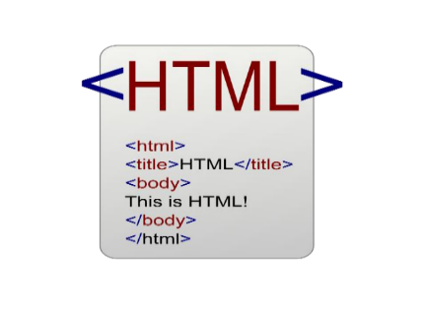

**Fig 4.1 HTML**

**4.2 CSS (Cascading Style Sheets)**

CSS (Cascading Style Sheets) is a fundamental style sheet language used to control the presentation of HTML and XML documents. Initially designed to separate content from design, CSS has become ahow elements should be displayed, CSS allows for a wide range of design possibilities, from simple color changes to complex animations and layouts.

One of the core features of CSS is its ability to apply styles to multiple elements simultaneously, reducing redundancy and ensuring a consistent look and feel across a website. CSS selectors, properties, and values provide a powerful syntax for targeting specific elements and applying styles. This flexibility is further enhanced by CSS preprocessors like Sass and Less, which introduce variables, nesting, and functions to streamline the development process and make stylesheets more maintainable.

Responsive design is a crucial aspect of modern web development, and CSS plays a vital role in achieving this. Media queries allow developers to apply different styles based on the characteristics of the user's device, such as screen size and resolution. This ensures that web pages are accessible and usable across a wide range of devices, from desktops to smartphones. Flexbox and Grid Layout are two advanced CSS layout modules that facilitate the creation of complex, responsive layouts without the need for floats or positioning hacks.

In addition to static styling, CSS also supports dynamic visual effects. Transitions, transforms, and animations enable developers to create smooth and engaging user experiences. These features can be used to animate element properties, rotate and scale elements, and create intricate animations, all while maintaining performance and responsiveness.

CSS is primarily applied on the client side, where the browser interprets the styles and renders the web page accordingly. CSS files can be hosted alongside HTML files or served from a Content Delivery Network (CDN) to improve load times and performance. Tools like CSS minification and concatenation further optimize the delivery of stylesheets, reducing file sizes and the number of HTTP requests.

In conclusion, CSS is a vital component of web development, providing the tools necessary to create beautiful, responsive, and user-friendly websites. Its ability to separate content from design, combined with powerful layout techniques and dynamic visual effects, makes CSS an indispensable technology for front-end developers. As web standards continue to evolve, CSS remains at the forefront, driving innovation in web design and ensuring a seamless user experience across all devices.

**Technologies Used:**

* **Preprocessors:** Sass, Less, and Stylus extend CSS with variables, nested rules, and functions, making stylesheets more maintainable and powerful.
* **Postprocessors:**PostCSS processes CSS with JavaScript plugins, enabling features like autoprefixing and custom property fallback handling.
* **CSS Frameworks:** Bootstrap, Foundation, Bulma, and Tailwind CSS provide prebuilt components and utility classes for rapid development.
* **Responsive Design Frameworks:** Bootstrap, Foundation, and others support responsive design with built-in grid systems and responsive utilities.
* **CSS-in-JS Libraries:** Styled-components, Emotion, and JSS enable styling directly within JavaScript, promoting component-based design and scoped styles.
* **CSS Grid and Flexbox:** Advanced layout modules in CSS that provide powerful tools for creating complex, responsive layouts without float-based hacks.



**Fig 4.2 CSS**

**4.3 Javascript**

JavaScript is a versatile, high-level programming language that is a core component of web development. Initially created to add interactive elements to websites, JavaScript has evolved into a powerful tool that can be used for a wide range of applications. This language enables developers to implement complex features such as dynamic content updates, interactive forms, multimedia handling, and much more, directly within the browser. Its ability to manipulate HTML and CSS makes it an essential part of the web development triad, alongside these other technologies.

One of the defining features of JavaScript is its event-driven nature, which allows it to respond to user actions such as clicks, form submissions, and keyboard inputs. This capability is crucial for creating a responsive user experience, where the web page reacts immediately to user interactions without needing to reload. JavaScript's asynchronous programming model, supported by features like callbacks, promises, and the async/await syntax, further enhances its ability to handle tasks such as data fetching and processing in the background, without blocking the main thread of execution.

Moreover, JavaScript is not limited to client-side scripting. With the advent of Node.js, JavaScript can now be used for server-side programming, making it possible to build entire applications using a single programming language across both the client and server environments. This unification simplifies the development process and allows for more seamless data exchange and logic sharing between the frontend and backend. Additionally, the extensive ecosystem of libraries and frameworks, such as React, Angular, and Vue.js, empowers developers to create scalable, maintainable, and efficient web applications.

In conclusion, JavaScript's rich functionality, ease of integration, and continuous evolution make it an indispensable language for modern web development. Whether it's enhancing the interactivity of a web page, building a robust server-side application, or developing cross-platform solutions, JavaScript provides the tools and flexibility required to meet diverse development needs. As the language continues to grow and adapt, it remains at the forefront of technological advancements, driving innovation in web technologies and beyond .



**Fig 4.3 JavaScript**

**4.4 PHP**

PHP (Hypertext Preprocessor) is a widely-used, open-source server-side scripting language designed specifically for web development. Initially created in 1994 by Rasmus Lerdorf, PHP has evolved into one of the most popular languages for building dynamic websites and web applications. PHP is embedded in HTML and executed on the server, allowing developers to generate dynamic web content based on user interactions, database queries, or other server-side processes.

PHP’s ease of use, flexibility, and ability to work seamlessly with databases like MySQL have made it a cornerstone of web development, especially for small-to-medium-sized websites and Content Management Systems (CMS) like WordPress, Joomla, and Drupal. PHP is platform-independent and can be deployed on almost any web server, such as Apache, Nginx, or Microsoft IIS, making it highly versatile.

One of PHP’s key strengths is its integration with a wide variety of databases, including MySQL, PostgreSQL, and SQLite, which allows developers to create powerful database-driven websites. PHP also supports numerous protocols, including HTTP, LDAP, and IMAP, and can be extended through thousands of available libraries, enabling developers to easily add functionality to their applications.

Technologies Used:

* Frameworks: PHP has a robust ecosystem of frameworks that simplify development, including:
  + Laravel: Known for its elegant syntax, MVC architecture, and rich set of features like routing, session management, and caching.
  + Symfony: A highly flexible, reusable PHP framework that provides many reusable PHP components.
  + CodeIgniter: Lightweight and fast, ideal for building small-to-medium-sized web applications.
  + CakePHP: Follows the MVC approach and comes with features like form handling, session management, and security.
* Content Management Systems (CMS): PHP powers popular CMS platforms such as:
  + WordPress: The most widely used platform for building blogs and websites, with extensive themes and plugins.
  + Joomla: Known for its flexibility and extensive community support.
  + Drupal: Used for building complex websites and applications with highly customizable features.
* Databases Integration: PHP natively integrates with databases such as MySQL, PostgreSQL, and SQLite, making it an excellent choice for dynamic web content.
* APIs and Web Services: PHP supports the creation of RESTful APIs and web services, enabling it to interact with mobile apps, third-party services, and JavaScript-heavy frontend frameworks like React and Angular.
* Security Features: PHP frameworks provide built-in security features such as CSRF protection, SQL injection prevention, and input validation to ensure secure web applications.
* Web Servers: Apache and Nginx are commonly used in conjunction with PHP for efficient web server hosting.
* Package Management: Composer is a widely used dependency manager for PHP, allowing developers to manage libraries and frameworks easily.
* Testing Frameworks: PHPUnit is a standard framework for unit testing in PHP applications, ensuring code quality and stability.
* Integrated Development Environments (IDEs):
  + PhpStorm: A full-featured IDE tailored specifically for PHP development, with advanced coding and debugging tools.
  + Sublime Text, Visual Studio Code: Lighter editors with support for PHP development through plugins and extensions.
* Version Management: PHP developers use tools like PHP-FPM for process management and XAMPP for local development environments.



**Fig 4.4 Php**

**4.5 MySQL**

MySQL is an open-source relational database management system (RDBMS) developed by Oracle Corporation. Known for its speed, reliability, and ease of use, MySQL has become the database of choice for many web applications and platforms. It is particularly well-suited for applications where structured data needs to be stored, retrieved, and manipulated. MySQL follows the Structured Query Language (SQL) standard, which allows developers to interact with the database in a consistent manner.

MySQL is often paired with PHP in the development of dynamic web applications. The combination of PHP and MySQL (commonly referred to as the LAMP stack when combined with Linux and Apache) is one of the most widely used setups for web hosting, powering millions of websites and applications globally. MySQL provides support for large-scale web applications and is known for its high performance in high-traffic environments.

Technologies Used:

* Storage Engines:
  + InnoDB: The default storage engine in MySQL, designed for high-reliability and transaction-safe operations. It supports foreign keys, ACID-compliant transactions, and row-level locking.
  + MyISAM: An older engine still used in some legacy applications, which is optimized for read-heavy operations and full-text indexing.
* Database Features:
  + Indexes and Keys: MySQL provides support for indexing and primary/foreign key relationships to enhance query performance and ensure data integrity.
  + Triggers and Stored Procedures: These features allow developers to automate repetitive database tasks and enforce business logic at the database level.
  + Replication: MySQL supports master-slave and master-master replication configurations, making it ideal for distributed applications and ensuring data redundancy.
* Data Security: MySQL includes features like SSL encryption, user roles, and permission control to enhance security in database management.
* Web Integration: MySQL seamlessly integrates with PHP for web application development. PDO (PHP Data Objects) and MySQLi (MySQL Improved) are commonly used to manage MySQL connections within PHP applications.
* High Availability Solutions:
  + MySQL Cluster: Provides a high-availability, high-redundancy architecture for mission-critical applications.
  + MySQL Replication: Ensures data is replicated between multiple MySQL instances, allowing load balancing and failover mechanisms.
* Backup Tools:
  + mysqldump: A utility that allows developers to back up their databases, ensuring data security.
  + MySQL Enterprise Backup: Provides incremental backup capabilities for enterprise-grade solutions.
* Query Optimization: MySQL offers EXPLAIN plans and query optimization tools that help developers optimize database queries for improved performance.
* IDEs and Management Tools:
  + MySQL Workbench: An official graphical interface tool for designing, developing, and administering MySQL databases.
  + phpMyAdmin: A web-based administration tool for managing MySQL databases, widely used in conjunction with PHP applications.
* Scalability: MySQL supports sharding (horizontal partitioning of data) and clustering solutions to scale applications as they grow, ensuring the database can handle increasing amounts of data and traffic.
* Data Types and Functions:
  + MySQL provides a rich set of data types (e.g., integers, floating-point numbers, dates, strings) and functions (e.g., string manipulation, date calculations, and aggregate functions) that support complex queries and data manipulation.



**Fig 4.3 Mysql**

When developing a car buying and selling website, MySQL plays a crucial role as the database management system, handling all the data storage and retrieval necessary for the platform's functionalities. MySQL helps organize and store various types of data, from user profiles and car listings to transaction details, ensuring the smooth functioning of the website. The database structure must be well-designed to accommodate the different aspects of the car sales process, including user accounts, car information, and communication between buyers and sellers.

The user data table is essential for storing information about the individuals using the platform. This includes both buyers and sellers, who will need to register with personal details such as name, email, password, contact information, and user type (buyer or seller). The car listings table will store data related to each car being sold, including the car's make, model, year, price, description, photos, and seller information. By linking this table with the user data table, the website can track which user is selling which car.

To provide a smooth and efficient user experience, MySQL's search and filter capabilities should be leveraged. For example, you might want to create an index on columns like car make, model, and price range, which allows for fast querying when buyers are searching for specific vehicles. The system should also support filtering by location, vehicle condition, and other parameters, enabling users to quickly find the cars that best match their needs.

A transactions table is also necessary to handle the buying and selling of cars. This table can track offers, final sales, and payment status, ensuring that buyers and sellers have a clear record of all completed transactions. MySQL will ensure data integrity by handling these relationships via foreign keys and ensuring referential integrity between tables.

For communication, a messaging system can be created, where buyers can contact sellers through secure messages. A messages table can be implemented, where each message between users is stored, allowing for direct communication through the platform. This helps maintain transparency and avoids sharing private contact details before the buyer or seller is ready to proceed with a transaction.

MySQL also facilitates user authentication and security. Passwords should never be stored in plain text; instead, they should be hashed using a secure hashing algorithm (such as bcrypt) before being stored in the database. This ensures that sensitive user information remains secure, even if the database is compromised. Additionally, MySQL can be used to implement role-based access control (RBAC) to define different user permissions. For example, sellers can add or update their car listings, while buyers can browse listings, make offers, and view car details. Administrators can have the highest level of access to manage the platform, approve new listings, or remove inappropriate content.

A key feature of any online marketplace is the ability to handle payment processing securely. While MySQL is not directly involved in the transaction, it can store payment details such as the transaction status (pending, completed, refunded), payment method (credit card, PayPal, etc.), and the date of payment. Integration with third-party payment processors is typically done via an API, but MySQL ensures that the transaction data is securely stored and updated as needed.

Lastly, reports and analytics are vital for both users and administrators. Administrators can use MySQL to generate reports on sales statistics, top-selling cars, user activity, and more. These insights can help in decision-making and improve the overall platform. By combining MySQL's querying capabilities with data visualization tools, administrators can track the health of the platform, monitor user interactions, and ensure smooth operations.

The design and architecture of the MySQL database for a car buying and selling website are critical to ensuring that the platform is both efficient and scalable. At the core of the system, the **users** table manages all user information, including unique identifiers, personal details, contact information, and user roles such as buyer, seller, or administrator. This table is essential for creating the foundation of the platform, allowing for role-based access control and managing permissions for various user actions. The car listings table is similarly central, storing essential information about each car listed for sale. Details such as the car make, model, price, mileage, condition, and seller information are all captured here, allowing buyers to search, filter, and browse listings based on specific criteria. Relationships between users and cars are maintained through foreign keys, ensuring that each car listing is tied to the seller's profile.

To manage the buying and selling process, the transactions table records all transactions between buyers and sellers, including transaction statuses, payment details, and sale prices. This table ensures transparency and traceability, allowing both parties to track the status of the sale, while also ensuring that the car listing status is updated accordingly once a sale is completed. A messages table facilitates communication between buyers and sellers, offering a secure platform for negotiation and inquiries. By storing all messages related to a particular transaction, the system ensures that all interactions are easily accessible and managed within the platform.

Security is a paramount consideration in the database design, particularly when handling sensitive user information. Passwords are hashed before being stored in the database to prevent unauthorized access, and SSL/TLS encryption ensures that data transmitted between users and the server is secure. The use of prepared statements for queries prevents SQL injection attacks, ensuring that the database remains protected from malicious attempts to access or alter data. Additionally, role-based access control ensures that each user has the appropriate permissions for their actions, preventing unauthorized access to sensitive features or data.

The MySQL database also supports various performance optimization techniques to handle large volumes of data. Indexing is used on frequently queried fields such as car make, model, price, and location, ensuring that search queries are executed quickly. Caching mechanisms such as Redis or Memcached can be employed to reduce the load on the database by storing frequently accessed data in memory, improving the overall speed of the platform. As the platform grows and user interactions increase, MySQL’s scalability features, such as partitioning and query optimization, allow the system to maintain its performance even as data volume grows.

Another crucial aspect of the car selling and buying platform is its ability to handle secure and seamless payment processing. While MySQL does not directly handle payment transactions, it plays a key role in storing payment details and tracking the status of transactions. Payment methods, transaction status, and amounts are all recorded in the transactions table, allowing for accurate tracking and reporting. By integrating third-party payment gateways like PayPal, Stripe, or Square, the platform ensures that payments are processed securely, while MySQL handles the task of storing transaction records and updating the system once payments are completed.

As the platform evolves, advanced features like location-based search and mobile app integration can be added to enhance user experience. MySQL’s spatial data types, such as GeoJSON and Point, can be used to support geo-location features, allowing users to search for cars within a specific radius or geographical area. Additionally, integrating a mobile application with the MySQL backend via RESTful APIs or GraphQL ensures that the platform is accessible across various devices, providing a seamless experience for users whether they are on desktop or mobile devices.

In conclusion, MySQL provides the necessary framework for building a robust, scalable, and secure car buying and selling platform. From user management and car listings to transaction processing and communication, MySQL serves as the backbone of the system, ensuring that all critical data is efficiently stored, processed, and accessed. By implementing strong security measures, optimizing performance, and preparing for future features, the database design ensures that the platform can grow and evolve while maintaining a high level of performance and security.

The search functionality of the platform is another vital aspect that must be optimized to ensure a seamless user experience. By implementing **indexing** on key attributes such as make, model, price, year, and location, MySQL can process complex queries quickly. This allows users to filter results by price range, car model, year, or even location, enabling them to find cars that best suit their needs. MySQL’s **full-text search** functionality can be utilized to search through detailed descriptions, ensuring buyers can also find cars by specific features. For location-based search, MySQL can handle spatial data types, making it possible for users to search for cars within a specified radius, based on their location. This feature significantly enhances the platform’s usability by providing an intuitive and efficient way to explore car listings.

Reporting and data analytics are essential for monitoring the platform’s performance and user engagement. By querying data from various tables, such as **transactions**, **car listings**, and **user activity**, the platform can generate detailed reports on sales volume, popular car models, and user interactions. These reports can offer administrators valuable insights into market trends, allowing them to make informed decisions. For instance, MySQL’s aggregation functions can help track the number of sales per month, average transaction values, and even identify slow-moving inventory. This information can then be used to optimize marketing strategies and improve the overall platform performance.

Moreover, the platform’s ability to integrate with external systems significantly enhances its functionality. By linking with third-party payment gateways like PayPal or Stripe, the platform ensures secure and smooth financial transactions. MySQL stores transaction records such as payment status, amounts, and transaction IDs in the **transactions** table, ensuring full traceability of payments. Additionally, integrating with external APIs, such as those offering vehicle history reports or real-time pricing data, enriches the car listings and improves the buying experience. This seamless integration ensures that both buyers and sellers have access to the most accurate and up-to-date information.

Lastly, as the platform grows, it is essential to design the MySQL database with scalability in mind. Using techniques like **partitioning** and **replication**, the platform can handle an increase in data volume and user traffic. Partitioning helps distribute large tables across multiple storage units, improving query performance, while replication ensures high availability and data redundancy. As the platform expands internationally, MySQL's support for **internationalization** allows the database to handle multiple languages and currencies, ensuring that users from different regions can interact with the platform without issues. These features ensure that the platform can scale and adapt to a growing user base while maintaining performance and reliability.

In conclusion, a robust MySQL database is fundamental to the success of a car buying and selling platform. It supports inventory management, advanced search capabilities, reporting, and integration with external systems, all while ensuring the platform remains scalable and secure. By leveraging the full potential of MySQL, the platform can provide a seamless, efficient, and user-friendly experience for both buyers and sellers, ultimately contributing to the success and growth of the online marketplace.

One of the most critical aspects of a car sales platform is the **user management system**, which ensures that every user, whether a buyer, seller, or administrator, has appropriate access and functionality. The user database stores crucial information about each individual, such as personal details (name, contact information), account credentials (username, password), and role types (buyer, seller, administrator). For security, passwords are stored using encryption algorithms like bcrypt, ensuring that sensitive data is protected from unauthorized access. A well-structured **users** table could include fields such as user_id, email, password_hash, role, last_login, and status, where status might indicate whether the account is active or suspended. This level of organization ensures that users can easily manage their accounts, while the platform maintains a high level of security.

Another critical table is the **car listings** table, which stores detailed information about each car available for sale. This table holds key attributes such as the car's make, model, year, price, mileage, and other features that buyers are likely to filter by. For instance, the table can include fields such as car_id, user_id (linking the listing to the seller), make, model, year, price, mileage, car_condition, and status. The status field could be used to indicate whether the car is "available," "sold," or "pending." In addition, a created_at and updated_at timestamp will allow tracking when the car listing was first posted and when it was last updated, enabling efficient tracking and management. Through relational joins with other tables, such as **users**, **cities**, and **transactions**, the car listings can be linked to sellers, locations, and sales activity.

For the car search functionality, advanced queries utilizing the **indexing** feature in MySQL are essential. By indexing commonly searched fields like make, model, year, and price, MySQL is able to quickly process user queries, reducing the time it takes to fetch results. An efficient search algorithm could combine different filters such as location, price range, car type, or specific features like the fuel type or transmission type. Additionally, indexing makes the experience more efficient when browsing through thousands of listings. For example, if a buyer wants to filter cars based on their preferred price range and model, the platform can deliver those results faster by querying indexed fields instead of searching through every row in the table.

The **transactions** table is another key part of the database schema. This table stores data related to the buying and selling process, including payment status, transaction dates, and transaction IDs, which are critical for tracking financial activities and generating invoices or receipts. Each transaction is linked to a car listing (through the car_id field) and a user (through the buyer_id and seller_id fields), ensuring that each transaction can be traced back to the parties involved. The transaction_status field tracks whether the transaction is complete, pending, or failed, while the payment_method field stores which platform (PayPal, Stripe, etc.) was used for payment. Additionally, the platform can store important data such as the transaction_date, amount, and payment_reference_number, enabling comprehensive tracking of the entire financial flow. Having this information in the database also ensures that administrators can generate reports for financial audits or monitor transactions for any potential fraudulent activities.

**Location-based searches** are another powerful feature that MySQL can support by using spatial data types. For example, the **cities** and **states** tables contain information about the geographic location of cars for sale, and by using MySQL's **spatial indexes** or the **geospatial functions**, users can search for cars based on proximity to their location. This feature could be useful for users who prefer to buy cars near them to avoid shipping costs or simply want to see what's available locally. The platform can store latitude and longitude coordinates in the **car listings** table, and with MySQL spatial queries, users can input their location and filter the results by proximity.

In addition to the core functionality of listing cars, the database should support **ratings and reviews**, allowing buyers to leave feedback about their purchasing experience. A **reviews** table can store the ratings (e.g., 1 to 5 stars), review comments, the user_id of the buyer, and the car_id of the car purchased. This feedback mechanism is essential for maintaining the credibility of the platform, as prospective buyers can check reviews before making a decision. The reviews could be displayed on the car listings page, providing social proof and improving the user experience. The platform can also aggregate ratings and show average ratings for each seller or car model, creating a transparent marketplace.

A **notification system** could be added to the platform, which is also managed through the MySQL database. The **notifications** table can store data regarding alerts such as new messages, updates on a car’s price, or notifications for users about their profile status. The notification_type field can help categorize the notifications (e.g., alert, reminder, message). Notifications ensure that users stay updated on their activities within the platform and encourage engagement. For instance, if a buyer expresses interest in a particular car, the platform could notify them if the car price drops or if a similar model becomes available.

For **administrators**, MySQL can be used to generate detailed reports on various aspects of the platform. By querying the **car listings**, **users**, **transactions**, and **reviews** tables, the platform can generate analytics to track performance metrics such as the number of active listings, total transactions, most popular car models, user activity, and even revenue generation. These insights can help platform administrators optimize the service, monitor inventory, and improve user satisfaction. Reports can also be used to assess how well the platform is meeting its business objectives and identify areas for improvement.

The **scalability** of the car sales platform is an important consideration. As the platform gains more users and transactions, the database must be capable of handling large volumes of data. To scale MySQL, database administrators can use techniques such as **sharding** (splitting the database across multiple servers) or **replication** (creating copies of the database for read-heavy operations). These strategies help ensure that the platform continues to perform well even as the user base grows. Additionally, **backups** and **data redundancy** can be implemented to safeguard against data loss, providing high availability and data integrity.

Finally, **security** is paramount when handling sensitive user and transaction data. MySQL supports various features to enhance database security, such as **role-based access control** (RBAC), which ensures that only authorized users have access to specific tables or queries. Furthermore, **SSL/TLS encryption** can be used to secure the connection between the database and the application server, protecting data from being intercepted during transmission.

*Chapter 5*

**IMPLEMENTATION DETAILS**

______________________________________________

In this chapter, we discuss the implementation of a web application designed to provide users with an efficient and intuitive experience for buying and selling cars. The application is designed to handle various essential tasks such as user authentication, car listings, browsing, buying, selling, and managing user profiles.

**5.1 Login Page**

The login page is crafted with a clean and intuitive design, providing users with an easy-to-use form layout, utilizing HTML and CSS for styling. The page includes labels and placeholders for each input field, making it user-friendly. JavaScript is used to validate user input on the client-side, ensuring that all fields are filled out correctly before submission. On the backend, authentication is handled by verifying the credentials against stored data in the database. Upon successful login, session management ensures that the user remains logged in securely. The system includes error handling for invalid login attempts, with mechanisms in place to lock accounts after multiple failed login attempts for security purposes.

**Implementation Details:**

* **Form validation**: Ensures required fields are filled out correctly.
* **Password handling**: Passwords are securely hashed using encryption algorithms.
* **Session management**: Manages the user’s logged-in state.

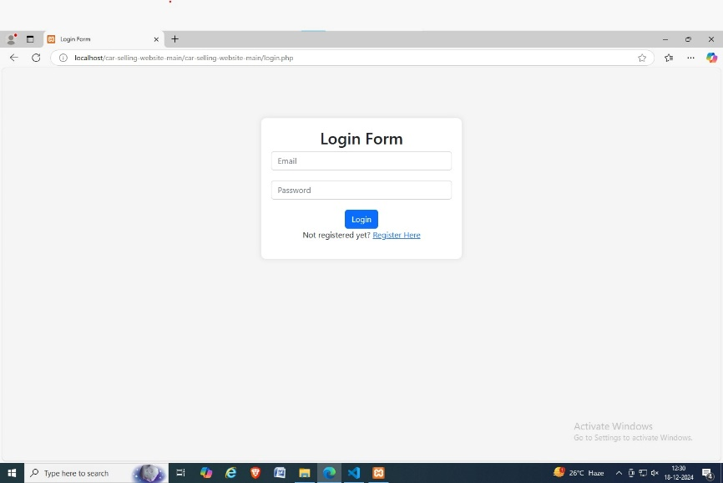

**Fig 5.1 Login Page**

**5.2 Register Page**

The registration page allows new users to create an account on the platform. Users are asked to provide personal and vehicle-related information, including their contact details and preferences for buying or selling cars. The page includes strong form validation, ensuring that all fields are filled correctly and in the right format. Upon successful registration, users can start listing cars or browsing available cars.

**Implementation Details:**

* **Form Validation**: Ensures email and password formats are correct, and all mandatory fields are filled.
* **Password confirmation**: The user is required to confirm their password during registration.
* **File Upload Validation**: Only allows image files for car pictures (e.g., JPG, PNG) and enforces size limits.
* **Secure Data Processing**: Passwords are hashed and other sensitive information is securely stored.

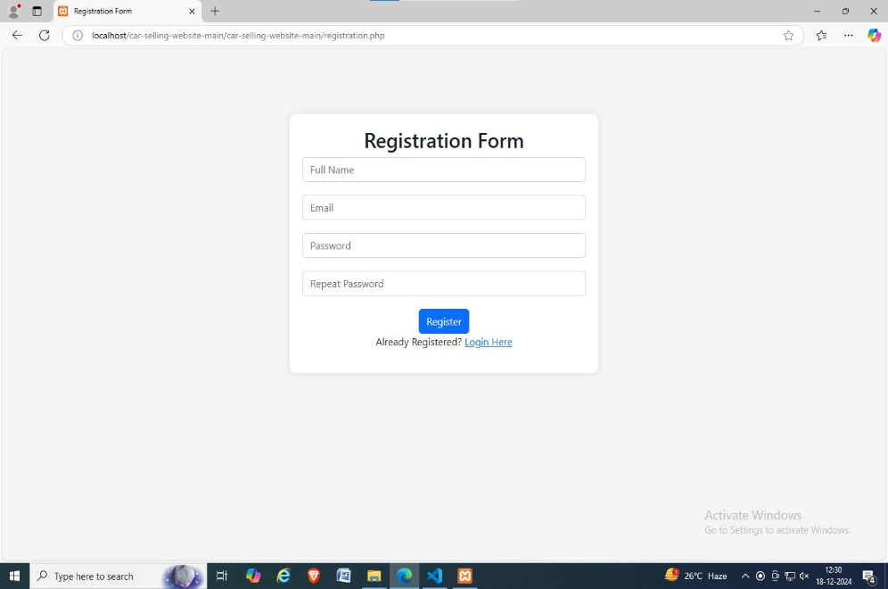

**Fig 5.2 Registration Page**

**5.3 Home Page**

The home page serves as the welcoming point of the web application. It features a navigation bar (navbar) that links users to essential sections of the site, including the "Buy" and "Sell" pages, and user profile. The home page also includes a dynamic carousel displaying featured cars or promotional content. The layout is responsive, ensuring it is easily accessible on desktop, tablet, and mobile devices.

**Implementation Details:**

* **Responsive Design**: The page adjusts to different screen sizes for accessibility on various devices.
* **Dynamic Content**: Highlights featured cars or new listings using a rotating carousel.
* **Navigation**: Easy access to core functionalities such as browsing car listings, user profile, or adding a new listing.



**Fig 5.3 Home Page**

**5.4 Contact Us Page**

The Contact Us page allows users to reach out to customer support or inquire about specific cars. Users can submit their name, email, and message through a simple form. The form includes validation to ensure that the fields are properly filled and that the email is in the correct format. Once submitted, the message is processed on the backend and sent to the customer support team. A confirmation message is displayed to the user to confirm successful submission.

**Implementation Details:**

* **Form**: Collects name, email, subject, and message.
* **Backend Processing**: Submits the form data via email to the support team.
* **Confirmation**: Displays a success message after form submission.

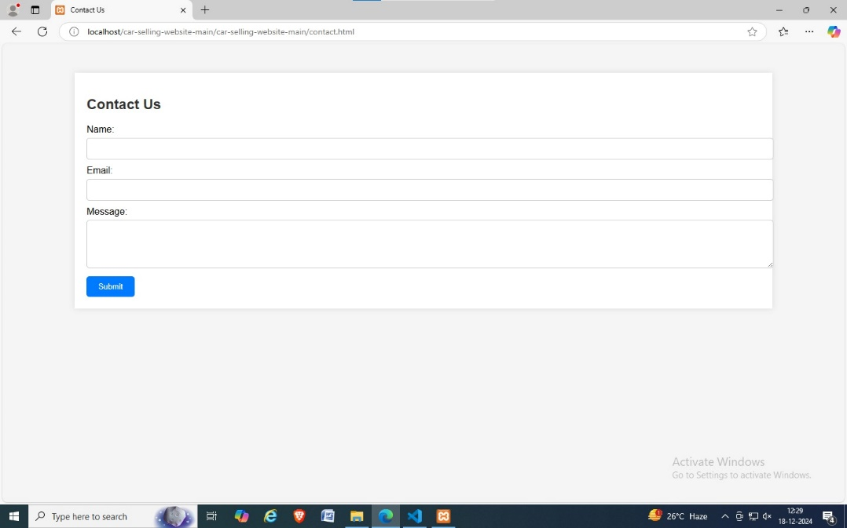

**Fig 5.4 Contact Page**

**5.5 Database Creation**

The database supports the car buying and selling process, containing several tables that manage various aspects of the system. Below is an overview of the database structure:

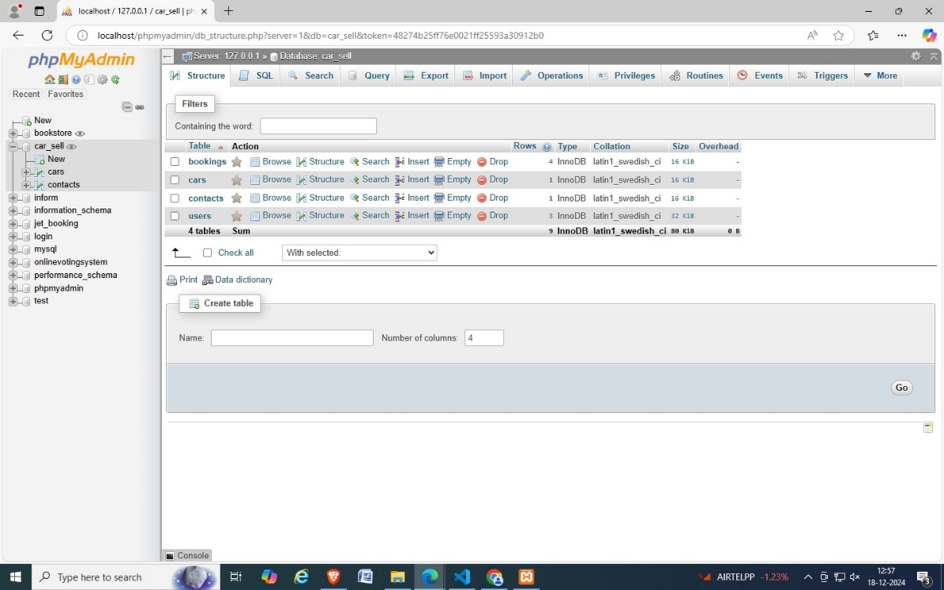

**Fig 5.5 Database**

**Database: car_sales**

This database consists of 12 tables, each serving a different function to ensure efficient management of the platform's data:

1. **admin**: Stores administrator information, including login credentials and management privileges.
2. **car_listings**: Stores data about the cars available for sale, including details like model, make, year, price, and seller info.
3. **cities**: Stores city data, used to filter car listings by location or to help buyers search for cars in specific areas.
4. **companies**: Contains information about car dealerships or companies that list cars for sale on the platform.
5. **countries**: Stores country data for international buyers and sellers, allowing them to list or search for cars globally.
6. **job_post**: (can be removed, not relevant for the car sales platform)
7. **inbox**: A messaging table where users can send and receive messages regarding car listings or inquiries.
8. **messages**: Stores feedback or inquiries sent through the "Contact Us" form.
9. **notifications**: Stores notifications and updates for users, such as sale promotions or new listings.
10. **replies**: Stores responses to messages in the inbox table, maintaining the conversation thread.
11. **states**: Stores state or regional data, enabling more precise search or filtering by location.
12. **users**: Contains user data, including personal details, contact information, and preferences related to buying or selling cars.

**CONCLUSION**

______________________________________________

The "Car Sales Platform" project successfully fulfills its objective of transforming the car buying and selling experience through a modern and efficient online platform. Designed with a focus on user-friendliness, the platform allows both buyers and sellers to easily navigate through its features. By enabling user registration, it allows buyers to track their inquiries, save their preferred searches, and manage interactions, while sellers can easily list their cars, update prices, and provide detailed descriptions along with high-quality images. The system integrates advanced search and filtering options, allowing buyers to refine their search by various parameters like price, make, model, year, mileage, and location, which significantly streamlines the search process. Additionally, it allows buyers to compare multiple cars before making a decision.

The platform also facilitates secure and private communication between buyers and sellers through its integrated messaging system. This feature allows for seamless interaction, where buyers can ask questions, negotiate prices, or arrange viewings, all within a secure and encrypted environment. Furthermore, the platform incorporates a payment gateway that ensures secure transactions, supporting various payment methods such as credit cards, debit cards, and online wallets. This provides a convenient and trusted transaction experience for both parties.

For the administrators, the platform provides a comprehensive dashboard that helps manage users, car listings, and transactions effectively. Admins can approve or reject listings, monitor activities on the platform, and ensure compliance with site rules. This level of control helps maintain a transparent and safe environment for everyone involved. Additionally, the system includes tools to report issues or disputes, making the platform more secure and accountable.

**REFERENCES**

______________________________________________

[1] Elizabeth Castro, Bruce Hyslop, “HTML5 and CSS3, 7th Edition”, Peachpit press, 2012. ISBN: 9870321719614

[2] Thomas A. Powell, “HTML & CSS design”, Mc Graw Hill, Inc 2010. ISBN: 9780071741705

[3] Raghu Ramakrishnan, “Database Management Systems”, McGraw Hill, the University of Michigan, 1988. ISBN:9780070507753

[4] Elmasri, S. Navathe, “Fundamental of Database Systems”, Person Education, 2015. ISBN: 978020156294

[5] H.Korth ,S.Sudarshan, A.Silberchatz, “Database System Concepts”, New York McGraw Hill Education, 2019. ISBN:97811260515046